# Create a Web Application in SharePoint Central Administration

A web application is a site collection that can host one or more SharePoint sites. A web application has its own URL, authentication method, and configuration settings. To create a web application in SharePoint Central Administration, follow these steps:

* Open SharePoint Central Administration and click on Application Management.
* Under the Web Applications section, click on Manage web applications.
* On the ribbon, click on New to create a new web application.

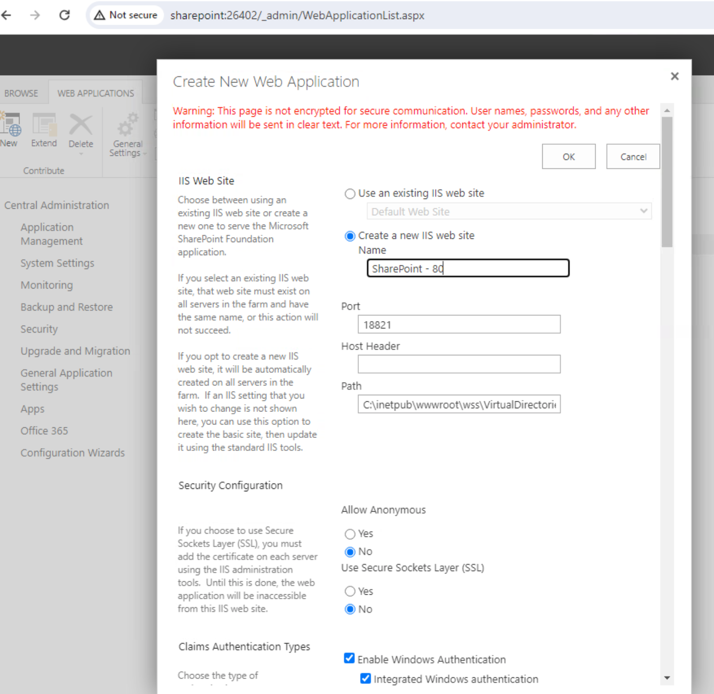

* On the Create New Web Application page, specify the settings for your web application, such as name, port, host header, path, security, and database.
* Click OK to create the web application. You may need to wait for some time while the web application is being created.
* After the web application is created, you can create a site collection for it by clicking on Create Site Collection on the confirmation page.